**BF[2] - Decomposition**

**Type in your score here 🡪 __20__ out of 25 points possible**

1. (5 points) Ponder/Reflect Exercise – Reflect on what you have learned from this portion of the class. Examples of what you can do are: a brief outline of material covered, insights you gained from class or personal study, or items you feel that you need to follow up or work on. (3-5 sentences)
   1. This week I have been able to learn about how interactions change up everything. I thought that I understood them decently, but the decomposition really through me for a loop. I really liked the questions on this homework that had us break down the data to understand the pieces better. That was helpful.
2. (4 points) #A1 on p. 207
   1. 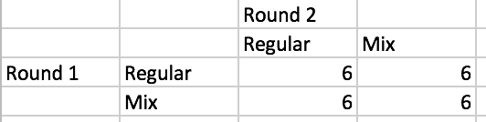
3. (4 points) #B3 on p. 214 (for part b only, also determine the number of treatment levels, and the experimental unit)
   1. First Factor = Personality A/B
   2. Second Factor = Gender
   3. Response = Time
   4. Interaction = gender and personality effect time spent on negative info.
   5. Levels = 4
   6. Unit = Student
4. (4 points) #B5 on p. 215 (for part b only, also determine the number of treatment levels, and the experimental unit)
   1. First Factor = Dandelion
   2. Second Factor = Habitat
   3. Response = Average number of plants per type
   4. Interaction = Habitat effects the number of plants.
   5. Levels = Twelve
   6. Units = Habitat

5. (8 points) Decompose, determine the degrees of freedom and create and ANOVA table for the wear data using wear2 as the response variable.





